# Design

## Provided Designs

Three boards are included in the initial project package, the IR LED sensor bar, the Power board, and the MCU board. The MCU board arrives soldered however the others must be soldered. This section will explain the function of these boards, as they must be understood in case they develop a fault, and for the designing of added peripherals.

### Sensor Bar

The first of the provided circuit designs to be discussed here is the sensor bar. The purpose of this circuit is to detect the white line on the track, and send this data to the MCU board so that the car can be controlled.

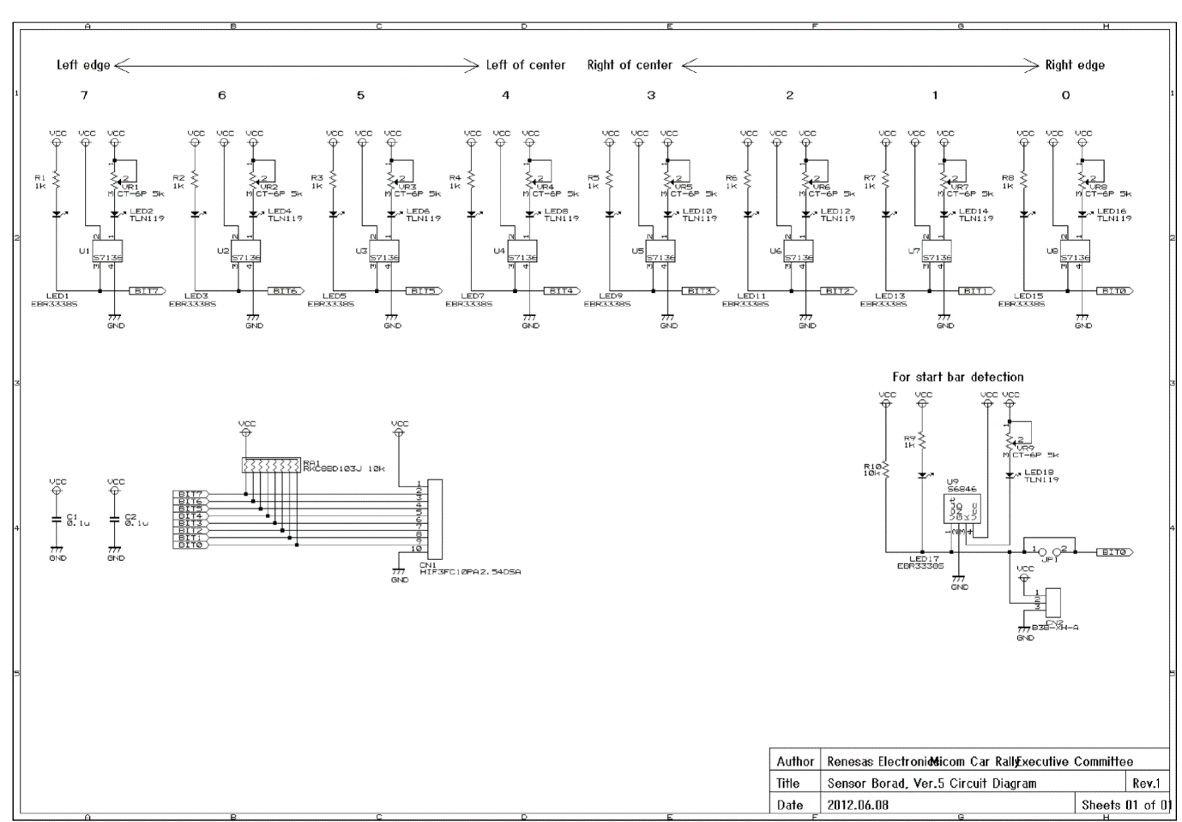

Above is the schematic for the sensor bar. As each of the LED-IR sensor sections are identical, one of them can be looked at as an example.

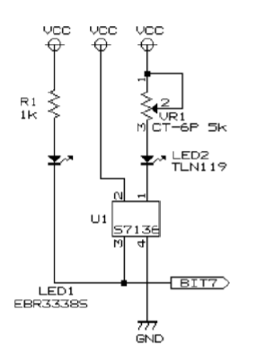The left most LED is a simple unicolour red LED in series with a 1k resistor. This LED has a forward voltage of 1.7V which means the current flow when on is . This LED will only be on when pin 3 of U1 goes low.

LED2 is the infrared LED which is in series with a potentiometer. As the resistance of the potentiometer is varied, the current supply, and thus intensity of light emitted varies.

Pin 1 on U1 is a cathode that sinks the current from the IR LED. Pin 2 is its power supply and Pin 4 is the ground. When U1 detects light, pin 3 goes low, turning LED1 on.

The start bar sensor works in almost the same way but shares the output Bit 0 with the right edge sensor. This means that during start up, the Bit 0 signal is used to detect the presence of the start bar, but then switches to detecting the right edge of the track.

This board is connected to the MCU via a 10 wire ribbon cord, with 8 signal wires, and 2 for Vcc and ground.

### Power Board

The power board’s function is to control and power the rear DC motors, as well as provide power to the servo and MCU. In its default state is can handle a power supply of 4.5 -5.5V, which is applied directly to the motors, the servo and the MCU board. However, with the addition of two linear regulators, it can be supplied with up to 7-15V. This increases the maximum speed of the DC motors and allows the use of more batteries in parallel, which in turn gives the car a greater on-board charge and battery life.

The schematic of this board can be divided up into sections.

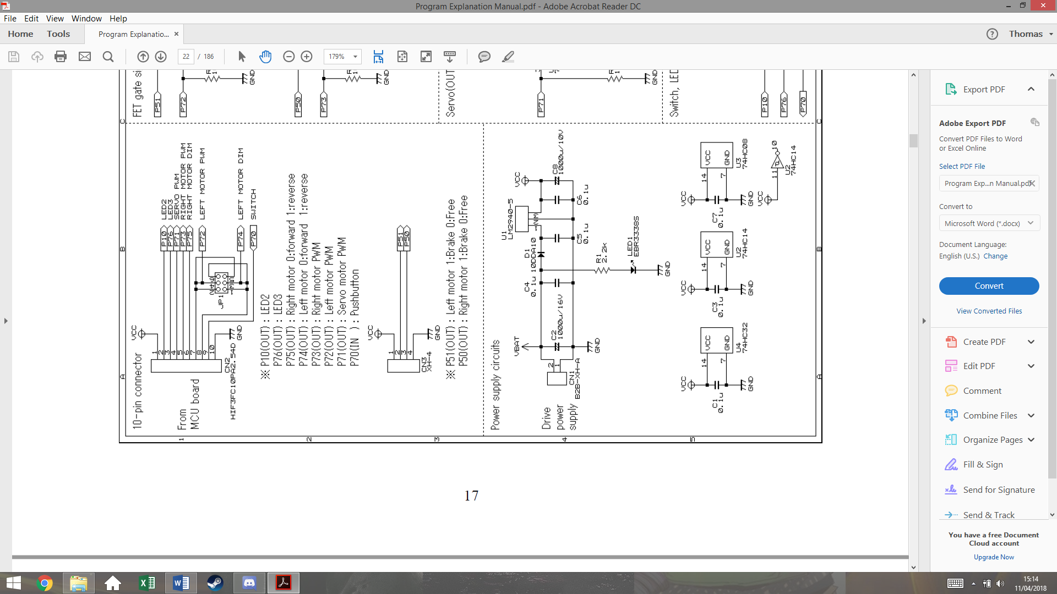This section shows the connections to the MCU board. Its important to be aware that the Vcc is connected **from** the power board **to** the MCU board.

The ribbon cord from the MCU contains the PWM signals for both motors, and the direction signal for each motor (0 forward, 1 reverse). The only purpose for JP1 is to switch the Left Motor PWM and LEFT Motor DIM signal for other boards. This also contains the pushbutton signal that will be used to run the car.

CN3 is for optional use, and can be used for braking the motors. This is specifically useful for the 90° turns. This would not allow for any dynamic braking as it would completely stop any signal sent to the motors.

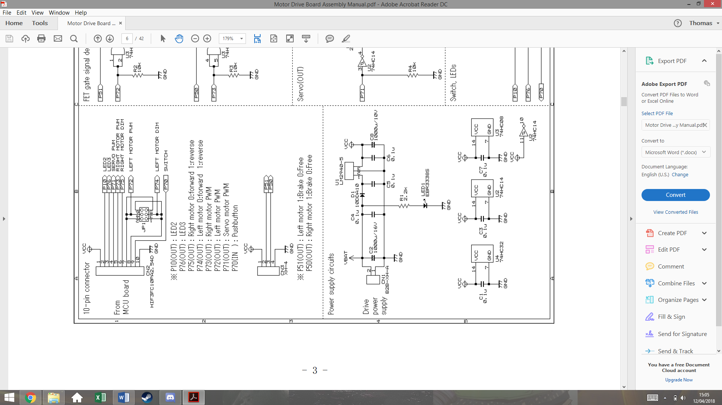This section shows the power supply of the board. The top circuit regulates the voltage supply Vcc for the MCU board. The LM2940-5 is a 5V regulator that is not included in the initial package. C5 and C6 are also not included so these must be purchased. LED 1 is simply used to indicated that the batteries are connected and that there is power.

The bottom circuit shows the Vcc connected to the logic chips U4, U2 and U3. The capacitors C1, C3 and C7 are decoupling capacitors that remove high frequency components on the supply, often cause by the power supply switching on. This stops the chips being damaged by inrush current.

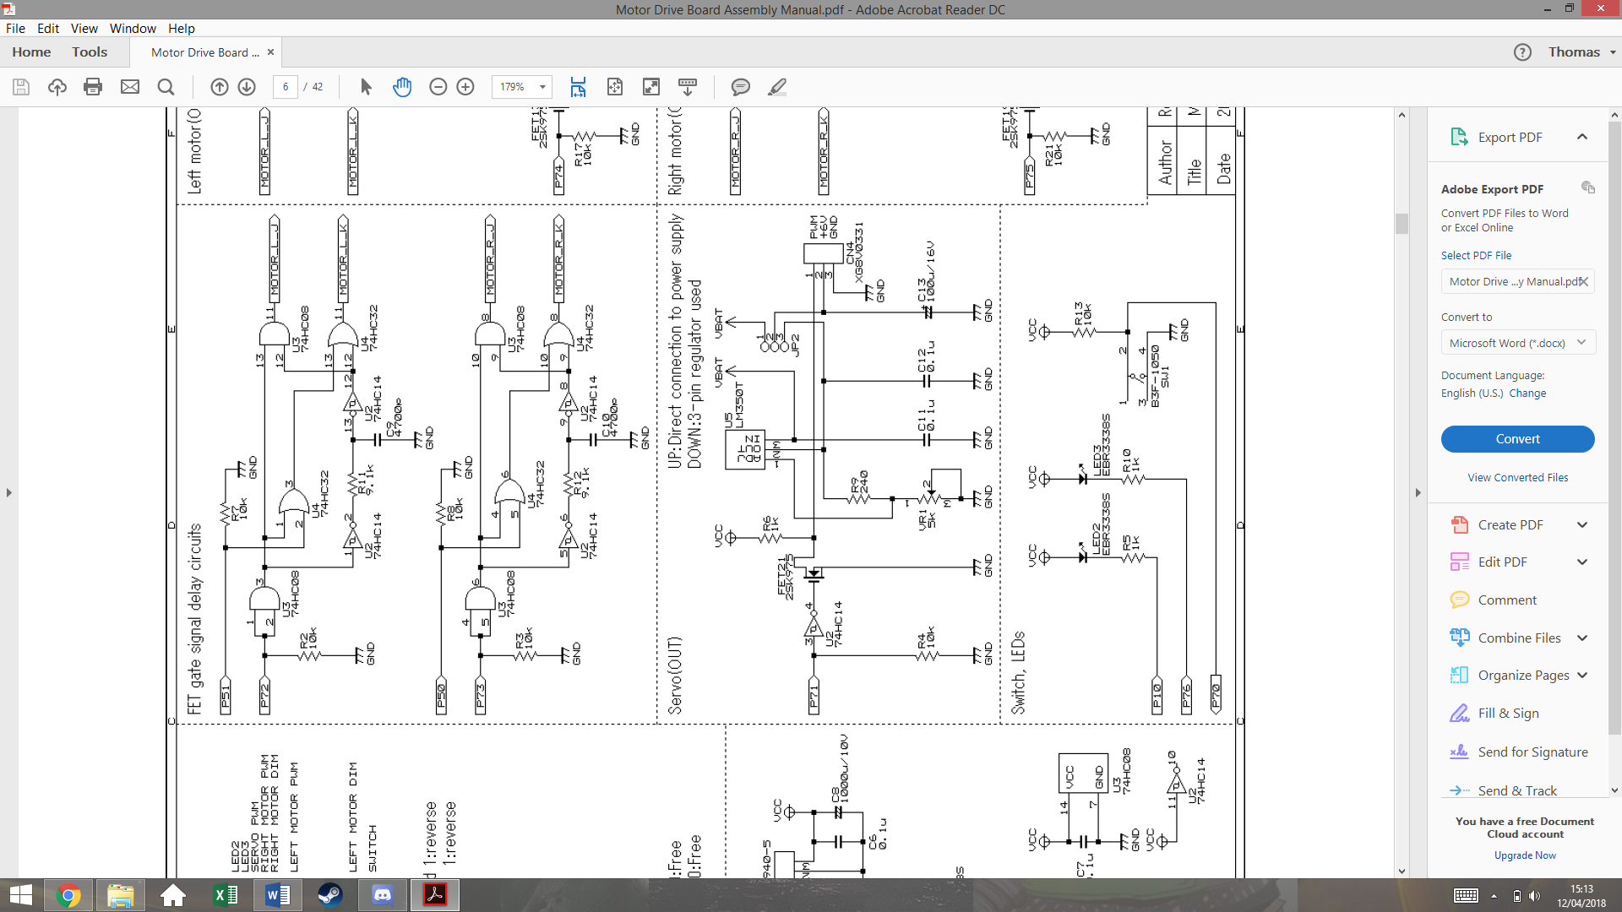This section shows the servo circuit. U5 is another linear regulator not included. This regulator is adjustable via the potentiometer VR1, which can be varied to give a 6V output. Jumper JP2 will have a short between pins 3 and 2, so connect the 6V output of U5 to the servo, instead of the battery voltage on pin 1.

U2 is an inverting schmitt trigger that both isolated the MCU, stopping current being drawn from the port, and inverts the PWM signal.

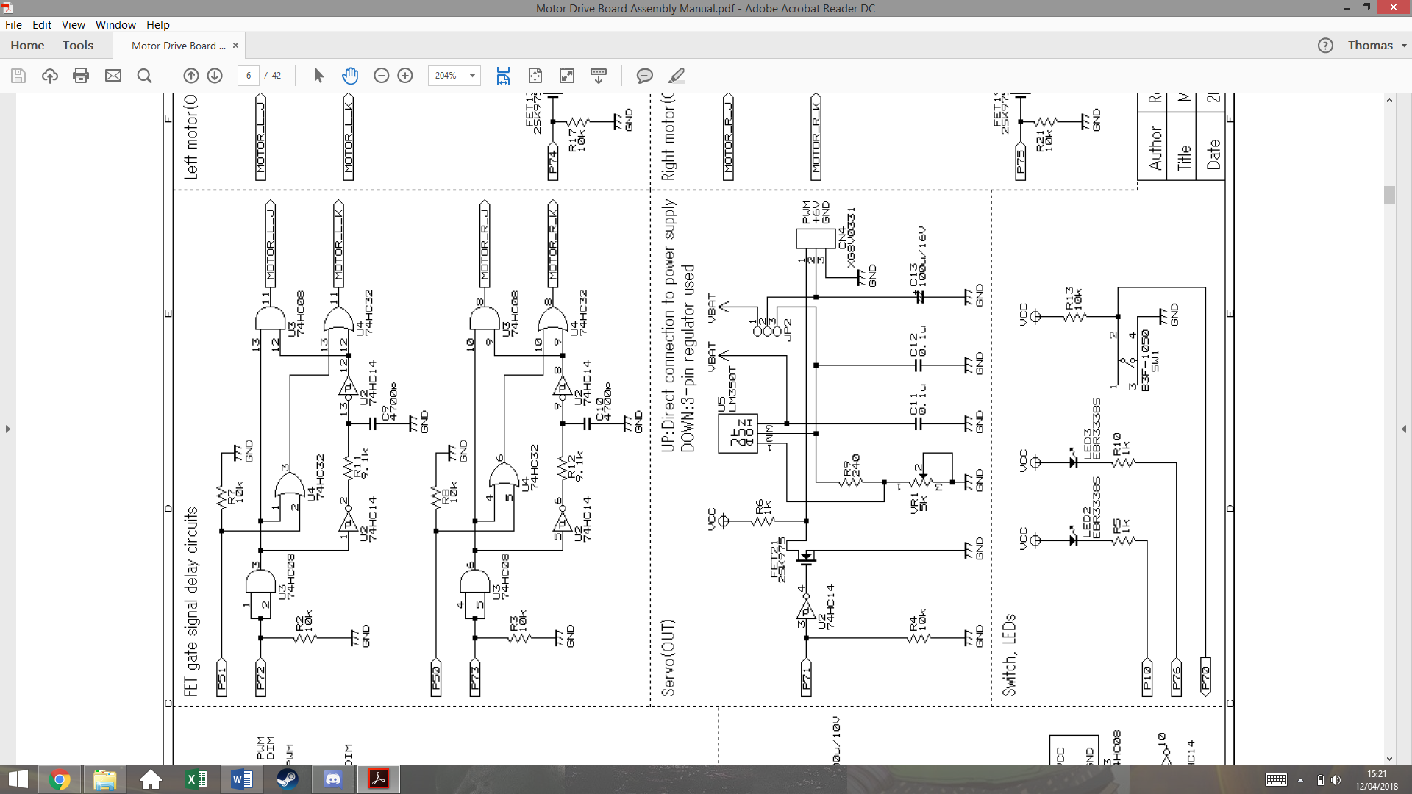

This section shows the logic circuits that control motor direction and speed. Both of these circuits are identical. The first AND gate acts as a buffer that isolates P72/73 on the MCU.

The output Motor_L_J is essentially just P72 but distorted with a delay, as it is the AND function of P72 before and after being filtered by R11 and C9. As it is filtered and then passed through a schmitt trigger, a delay is created.

The purpose of this delay is to stop a short in the circuit that could be created later. For now, its easier to understand with the removal of P51.

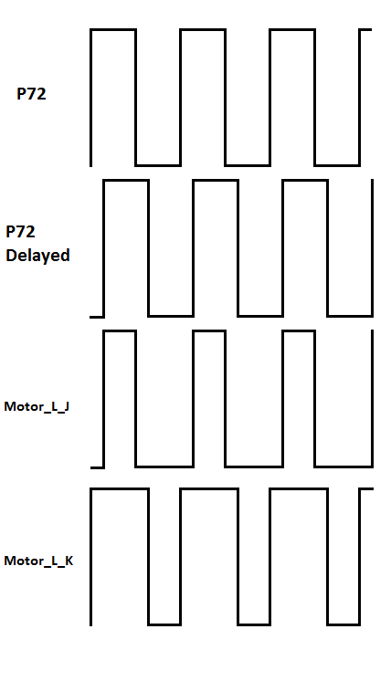This trace shows the output signals of this section of the circuit, without P51. The output Motor_L_K gets inverted by K-FETs in a later circuit. This explains how the short is prevented.

This final section of the power board is the transistor circuit that controls the motors. The bottom and top circuits are the same, but for the two different wheels. The circuit is made of p-channel and n-channel mosfets. Its important to remember that n-channel allow current flow when the gate is high, whereas p-channel allow current flow when the gate is low.

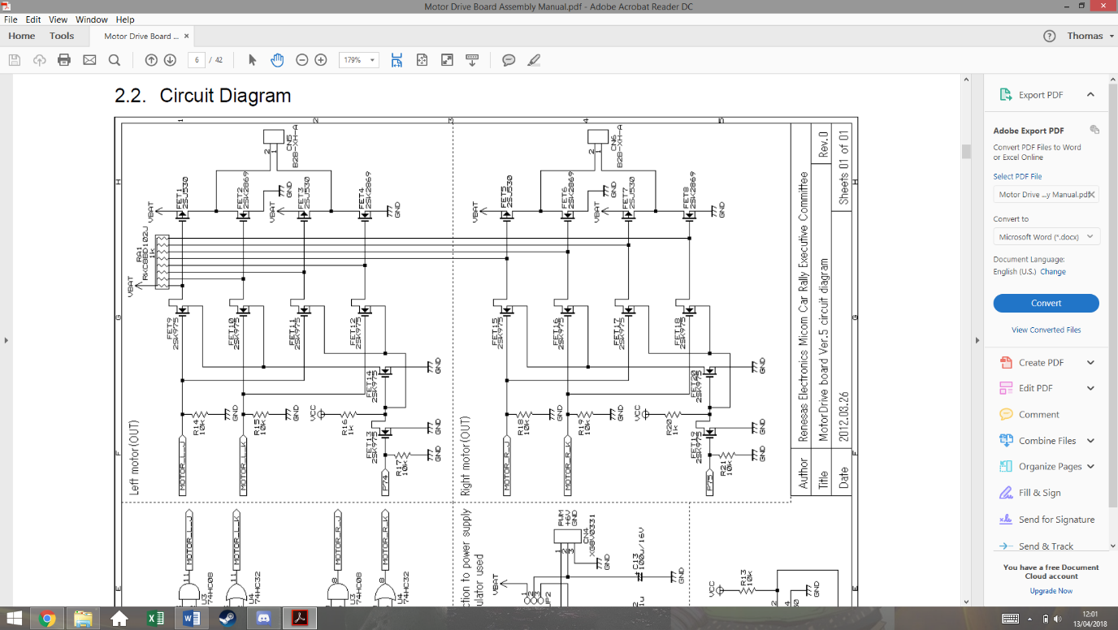

1

2

3

FET 1, 3, 5 and 7 are p-channel mosfets, the rest are n-channel

The resistor array functions as pull up resistors for the circuit. This means that if all of the FETs on the left and side are in an off state, the gates of the FETs on the right will be high. This will turn the p-channel FETs off and the n-channel FETs on.

If P74 is low, FET13 is off which turns FET14 on. This connects the source of FET9 and 10 to ground. This also connects the source of FET 11 and 12 to Vcc. This means they are not functioning and keep the signal at there drains high, which hold pin 1 of the motor to ground.

The signal traces for 50% pwm earlier can now be used to analyse this design at points 1, 2, 3 on the schematic. This example has P75 as a value of 0.

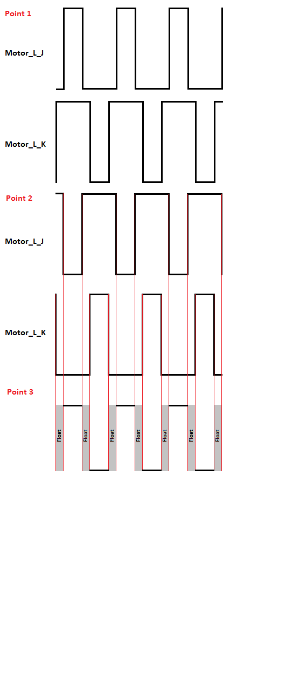The first trace shows the previously derived waves for input Motor_L_J and Motor_L_K. These signals go to the gates of FETSs 9, 10, 11, 12.

Point 2 shows the signals on the drain pins of FETs 9 and 10, and on the gate pin of FETs 1 and 2. Due to the pull up resistor, when FET 9 or 10 are low, the signal is high, and when the FETs are allowing current flow, the signal goes low, creating this inverted wave.

Point 3 shows how these signals effect this side of the motor input. Due to FET1 being a p-channel FET, when is gate signal is low, it conducts. This produces the wave form at pin 2 of the motor. The delay has created a period when the pin is not connected to Vcc or ground. This is for safety as if they were ever both connected, a short would be created.

If P74 is on, these same signals will be produced but with FETs 11 and 12 instead, while the outputs of FET 9 and 10 would hold pin 2 of the motor at ground. This effectively applies the same signal but with the pins switched around, reversing the motor.

## Speed Control and Feedback

In order for the car to handle optimally, forms of speed control need to be implemented, so that the car can brake and accelerate dynamically. With one or two feedback methods, a closed loop PID system can be created.

After some brief research, three methods of speed feedback were found, each with their own disadvantages and advantages.

Optocoupler- An optocoupler is made from an IR LED and an IR sensor, which will generate a pulse every time light is able to travel between them. This would be implemented by cutting holes in one of the gears and placing the optocoupler across them. The advantage of this is its low cost but would be larger than the alternatives. It would also have to be placed inconveniently above the gearbox, making it hard to get to for fault finding. The decision was made not to implement this method however it would be kept as a backup plan.

Hall Effect Sensor- A hall effect sensor is a small IC that will turn on or off depending on the magnetic flux present. This would require magnets to be attached to the real wheels so that the sensor would produce a square wave, with a frequency matching the wheels rotational speed in revolutions per second. The advantage of this is that the sensor would be placed right next to the wheel, making it much easier to access that the optocoupler. The main disadvantage is the need to attach magnets to the rear wheels, slightly increasing the load. This method was decided to be our main form of speed sensing.

Accelerometer- While normal used to measure acceleration, and accelerometer could be used with software integration to indirectly measure the speed. The method has the advantage of not having to change the mechanical design in any way, but as it is not a direct speed measurement, it may not be very accurate. This was decided to be a secondary measurement for speed, as well as helping dynamic braking and acceleration by giving acceleration feedback.

### Hall effect Sensor

A hall effect sensor is and IC that can detect the presence of a magnetic field. They’re often used in motor control to measure rotating magnetic fields. The image below shows and example.

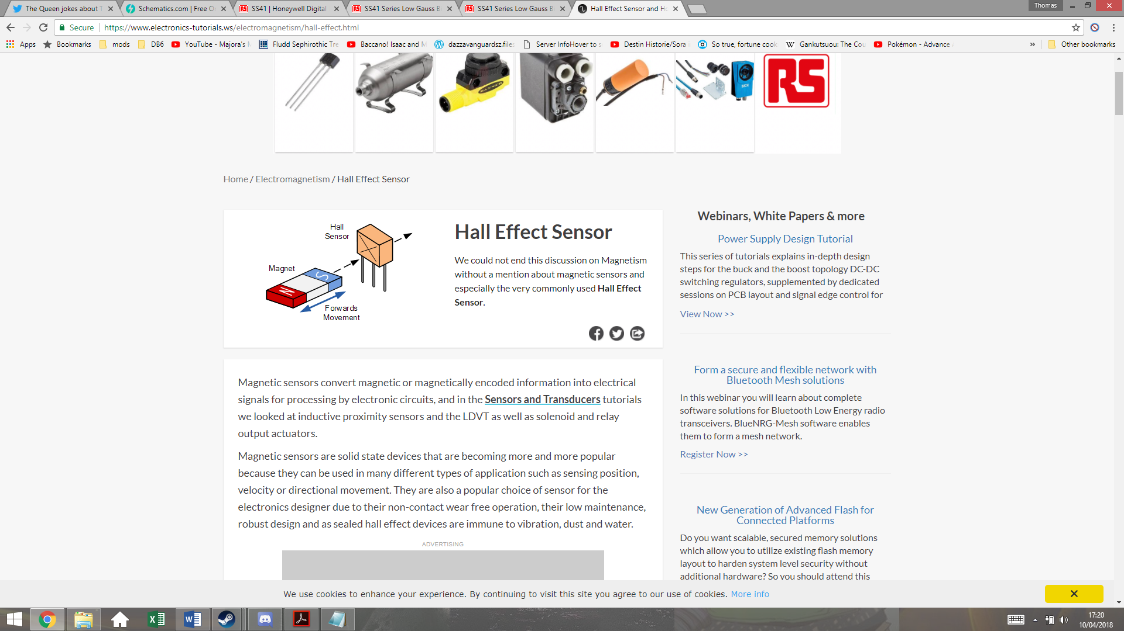

As a southern pole passes in front of the sensor, the output voltage goes high, and as a northern pole passes in front of the

sensor, the output will return low. If the magnetic field is removed, it will maintain the same voltage. Meaning that it requires both poles to create an alternating signal.

Figure 1- Credit www.electronics-tutorials.ws

Both of the rear wheels will have two magnets attached on opposite sides to create a rotating magnetic field. These magnets will be attached with superglue, which should be enough to hold them even when the car is traveling at full speed. The magnets have to be placed exactly opposite each other, or this will create an unbalanced load on the DC motor. The magnets that will be used are Eclipse 5mm Neodymium Magnetic Discs, which are small but powerful. The diagram below shows how they will be positioned.

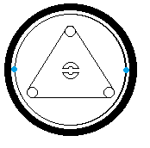The magnets will be placed on the rim of the wheels, next to but not touching the tire. The roll bar connector in the centre of the wheel can be used to make sure they are aligned with each other. These two magnets must be polar opposite so that they switch the sensor on and off with each rotation.

The hall effect sensor chosen is the SS41 Honeywell Digital Hall Effect Sensor. It has an input voltage range of 4.5-24V, meaning that its suitable to be run of the Vcc of the MCU board. Its maximum current draw when switching with a voltage supply of 5V is 8.7mA, which shouldn’t impact battery life significantly.

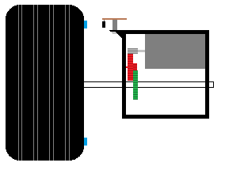

Hall effect sensor

Magnet

This image shows how the sensor must be positioned. The sensor is soldered onto a small piece of Veroboard, which is attached to the gear box using a screw and a spacer. The spacer is to keep it at the same level as the magnet. There is an airgap between the sensor and the magnet, but this should not be large enough to present a problem, given the strength of the magnets used.

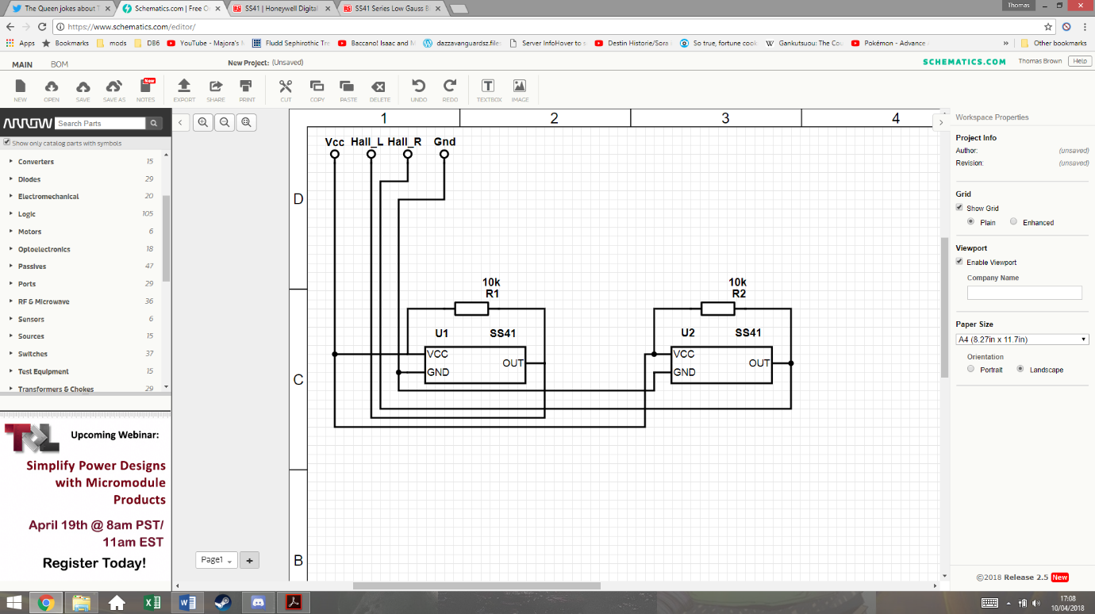This schematic shows how the system will be connected. The two hall effect sensors have pullup resistors that prevent any floating values. They both share the Vcc and ground from the MCU board. The two outputs are then connected to I/O pins on the MCU board.

### Accelerometer

The use of an accelerometer in the car control allows the program to know the forces acting on the car. This can help prevent the car coming out of the track due to inertia and can also help breaking for the corners. For this application, only a two-axis accelerometer is required, as there should be no forces acting on the car perpendicular to the ground.

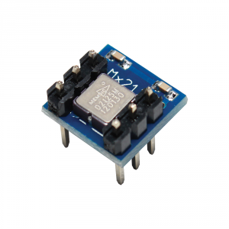The accelerometer chosen is the MESMIC 2125 two axis accelerometer. This can easily be inserted and removed from a standard 6 pin IC socket.

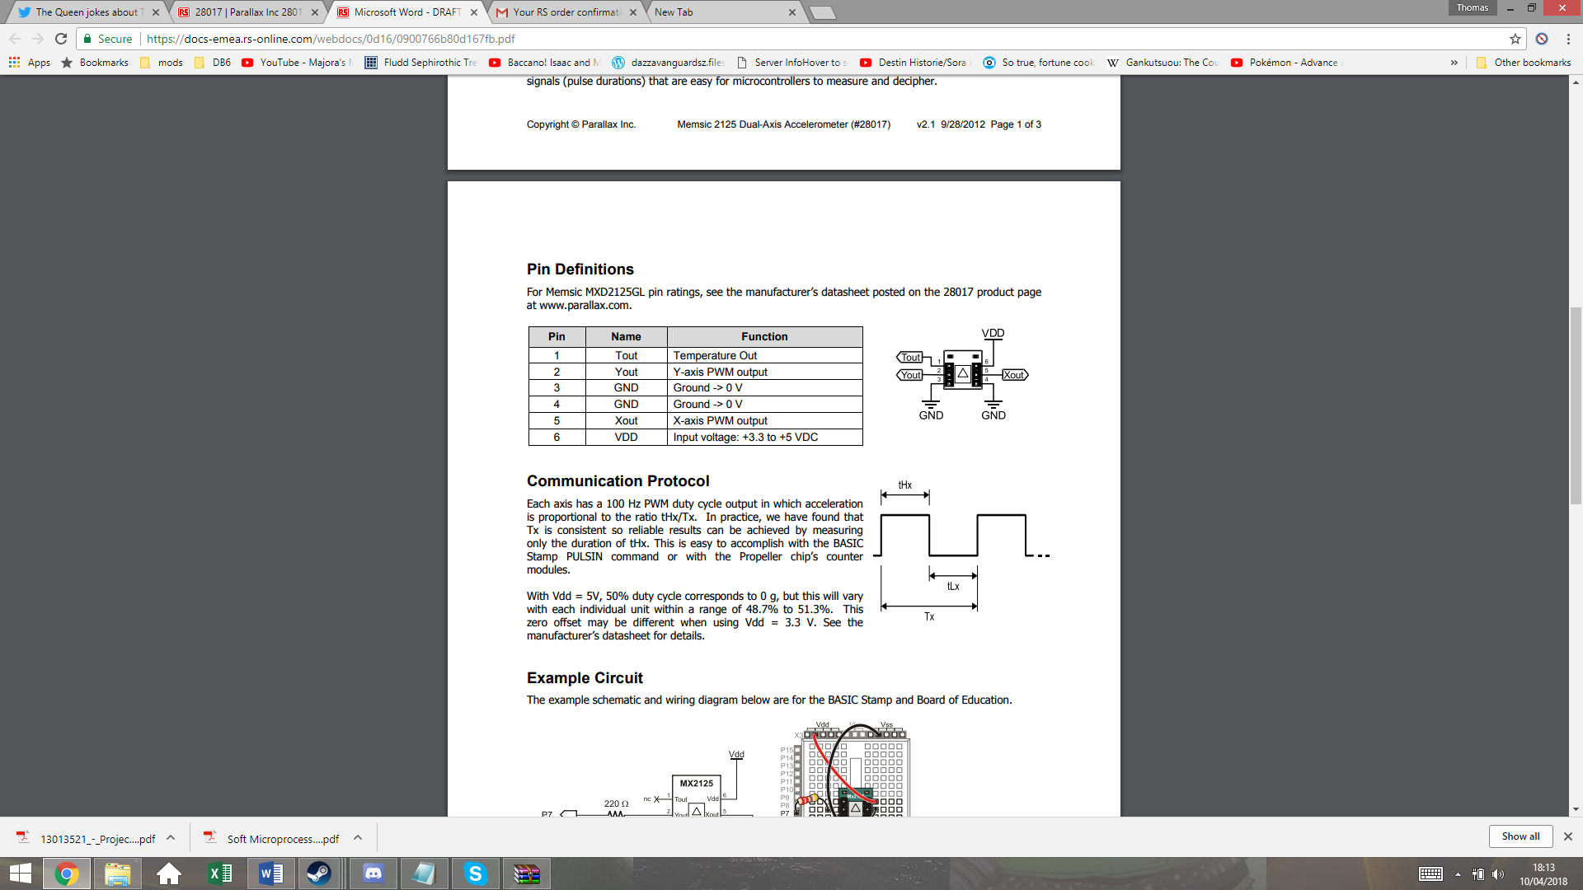

The supply voltage range for this device is 3.3-5Vdc, so this can also be run from the MCU boards Vcc. The output Xout and Yout will be used to give the X and Y coordinates of the vector of acceleration. These output give PWM signals, with duty cycles that vary in proportion to acceleration.

Tout is the temperature output from a thermistor inside the IC, but this will not be used in this system.

The datasheet states a sensitivity of 12.5% duty cycle per g on both axis, with 50% duty cycle representing 0 gg. This gives a range of +/-3 g. Taking g to be 9.81m/s^2, this gives a maximum measurable acceleration of 29.43m/s^2, which the car should not be able to exceed.